**ATDRL UTALIZATION SAFETY AGREEMENT**

Aug 2023

**ATDRL UTALIZATION SAFETY AGREEMENT**

This agreement documents consist of 11 pages and describes the terms on which ATDRL offer you access to its interactive research services. This offer is conditioned on your agreement to all of the terms and conditions contained in ATDRL application and utilization forms, including the policies and terms linked to or otherwise referenced in this Agreement, all of which are hereby incorporated into this Agreement.

By using ATDRL facility and having ATDRL services, you agree to and accept the terms mentioned in this ATDRL UTALIZATION SAFETY AGREEMENT in the following sections. The headings and subheadings are for your convenience only. You are responsible for reviewing all sections, defined terms in their entirety to ensure you fully understand this agreement document. In case of disagreement in any part of this agreement, you should decline this Agreement, in which case you are prohibited from accessing or having ATDRL Service.

**TABLE OF CONTENTS:**

1. ATDRL Safety rules and Regulations.
2. Lab Safety measures & Housekeeping
3. Receiving of samples
4. Appendix (Incident Report)
5. ATDRL user safety contract

**A. ATDRL Safety Rules and Code of Conduct**

* *Act* ***Professional and be polite,*** *respectful to other people and ADTRL STAFF.*
* *Use ADTRL facility for* ***research purpose*** *only.*
* ***Users and staff*** should know the emergency and Disaster Centre phone number (695-0999), locations and operation of all safety Equipment. This includes fire extinguishers, eye washes, first aid kits, the nearest emergency exit from their room, and the assigned assembly area.
* ***No food or drink*** is allowed in any ATDRL facility. Lunches, thermoses, and water bottles can be stored inside backpacks.
* ***Always wear goggles*** when you work with chemicals, hot liquids, or other materials that could harm you. Use caution when working with organic solvents if you wear contact lenses.
* ***Wear gloves*** while working in the laboratory. Please let us know if you have an allergy to latex.
* ***Please inform*** the instructor if you have allergies or asthma or think you might be pregnant.
* ***Always wear*** the proper clothes including long pants covering the entire leg and closed-toe shoes and lab gown during work for protection.
* ***Always alert your authorized lab personnel*** to any spills on your skin or clothing.
* ***Never taste or smell* ANY chemicals unless you are sure it is safe to do so. It is your responsibility to learn and understand the hazards of the chemicals you use before start using those chemicals.**
* ***Tie or pin long hair, scarves,*** and headwear out of the way to avoid contact with flames or chemicals.
* ***Be sure*** that you know how to use the equipment before beginning any work. If you are unsure, please ask for advice.
* ***Children*** are not allowed in the laboratory.
* ***Broken glassware*** or sharp metal pieces should be placed in “sharps” boxes (also labelled “broken glass”) unless it is contaminated with body fluids or microorganisms. Contaminated sharps should be placed in an appropriate labelled metal or glass container for sterilizing.
* ***Organic compounds fluids*** (e.g., PMMA, acetone, chloroform) **or** other volatile liquids should be used inside a fume hood.
* ***Chemical waste*** should NEVER be placed in a sink drain without permission. Please consult the lab instructor in all cases.
* ***Media with microorganisms*** (liquid or solid) should be placed in a Biohazard bag or labeled autoclavable beakers for sterilizing and disposal.
* ***All glassware*** should be rinsed after use and test tubes placed upside down in the racks provided. Slides and coverslips should be discarded. Please be careful from equipment that offers a **mechanical hazard** to the eyes/body.
* ***Area should be cleaned up*** after use. Verify the lab is clean, organized and anything else required to make lab look professional and safe.

**B. Lab Safety Measures and Housekeeping**

Keeping your lab clean and well-organized is an important part of research safety. Clutter can lead to accidents and spills and can help fires spread faster. Cleaning your lab regularly will help keep everything organized, well-labelled, and safe. The cleaner and more organized your lab is, the easier it is to keep safe and in compliance.

Everyone working in the lab must act in a professional, safe, and environmentally responsible fashion otherwise it becomes difficult for anyone to get any work done.

We all need to make sure we all follow the lab rules and regulations, policies and procedure about safe work environment and practice.

The following sections include measures to be considered in safety and housekeeping:

***A. Chemicals***

* Keep chemicals stored in the appropriate cabinets or designated storage rooms when not in use (NOT IN FUME HOODS). Only obtain an amount to keep your test or research going, like a one day/week supply. This will free up lab bench space and, if you do have a spill, it will minimize the amount of chemical released.
* Put away all reagents, samples, and personal materials.
* Keep the lids on chemical containers. This sounds obvious but it will effectively reduce the possibility of a spill and reduce any fumes released into your lab and it’s the law.
* Label all containers. Make sure there are no unidentified containers; reagents, samples, drying papers with sample, or crucibles/boats with samples. Label all material by chemical name (Not just initials).

***B. Cleaning your working area***

* Properly dispose of old or unwanted chemicals or any unnecessary items.
* Damp wipes all benchtops until clean and areas near weighing stations.
* Place absorbent paper near weighing stations or anywhere else necessary.
* Clean up inside fume hoods.
* Look inside all cabinets for leftover waste and any storage hazards.
* Dispose broken glass trash and “sharp” bins.
* Recycle paper and cardboard should properly remove.
* Unused or spare equipment should be stored in a designated storage room/area.
* Equipment or furniture should not block walkways, electrical panels, or emergency eyewash.
* Check emergency egress path is maintained.
* Verify the lab is clean, organized and anything else required to make lab look professional.
* Check for trip and slip hazards (oil leaks from pumps, electrical cords, or hoses across the walking path.

***C. Fume Hood***

* Always work with the sash at the level of the arrow stocker and close when not used.
* Hoods are equipped with the airflow monitor and alarm to warn you if the air velocity is too low. If the alarm engages, lower the sash slightly until the alarm stops. If the alarm sounds consistently, this indicates a real problem immediately report to the lab staff.
* Store the bare minimum of equipment and chemicals in your hood. Excess materials will block the air flow and reduce performance significantly.
* Chemicals should not be stored in the fume hood.
* Keep the lab windows and doors closed. Draft from open windows and doors can significantly affect your hood’s performance.

***F. Safe storage of chemicals***

* Store using the following criteria: *Flammables, Corrosives, Oxidizers, Carcinogens, Water reactive, Toxics*.
* Acids: Store bottles in the acid cabinets, segregate oxidizing acids from organic acids, and flammable materials.
* Segregate acids from bases, and from active metals such as sodium etc..
* Segregate acids from chemicals which could generate toxic gases.
* Flammable: Keep away from any source of ignition (flame, heat, or sparks).
* Oxidizers: They react violently with organics. Keep away from flammables, from reducing agents, store in a cool, dry place.
* Store chemicals in containers compatible with, and durable enough for the waste. Liquid must be in screw top containers. Do not overfill container, allow for expansion.
* Store chemical waste in a designated area. Label area as, “Hazardous Waste Storage Area”.

***G. Gloves***

* There are 2 types of gloves in the lab:
  + **Latex gloves**: The most affordable option, but not as durable as nitrile gloves. They also offer limited protection against some chemicals.
  + **Nitrile gloves**: more durable than latex gloves, but less flexible. They offer good protection against most chemicals.
* Before conducting your experiment, make sure that the gloves are appropriate, compatible and chemical-resistant gloves.
* For most applications thin gloves are superior to heavy gloves because they offer better dexterity. However, some materials are toxic that only thick gloves are acceptable.
* People handling hazardous materials must discard their gloves before touching anything in the lab. This includes switches, electric sockets, door handles, computer keyboards, instruments, and telephone. Users are responsible for providing the appropriate PPE for all types of electrical, thermal, and chemical hazards.

***H. Compressed Gas Cylinders***

* Oxygen and any flammable gas must be in metal tubing. Teflon tubing is often a great choice but is more expensive than other materials. Except for very low pressure and as a short transition piece, soft PVC is a never good choice for gas.
* Compressed gas cylinders must be handled carefully by trained individuals. The diffusive nature of gas can result in serious hazards over large areas.
* Gas cylinders can be hazardous because:

a) If they are mishandled, they can become “unguided missiles” with enough explosive force to go through concrete walls due to high pressure inside the tank.

b) They often contain materials which are inherently toxic or highly flammable. For these reasons, particular care must be exercised with compressed gases.

* To transport or move a cylinder, strap it to a hand-truck in an upright position. Make sure the valve protection cap and outlet plug are in place. Leave the valve protection always cap on unless the cylinder is in use.
* Do not move a cylinder by rolling, dragging, or walking it across the floor. Never leave a cylinder free-standing.
* Never drop cylinders or bang them against each other or another object.
* All cylinders must be secured upright with chains and brackets bolted to a solid structural member. Chains should be 3/16-inch welded link or equivalent. At least one chain must be used to secure each cylinder at a point two-thirds up the cylinder’s height.
* Keep cylinders away from heat and sources of ignition.
* Do not place cylinder where contact with any electrical circuit can occur.
* Protect cylinders from weather extremes, dampness, and direct sunlight.
* Inspect cylinders and delivery equipment routinely for signs of wear, corrosion, or damage.
* All cylinders must be clearly labelled as to their contents. DO NOT USE unlabelled cylinders and do not rely on colour coding for identification. Understand that “Empty” implies “end of service” and as such, the cylinder may still have greater than 25 psig of pressure remaining.

***I. Power Failure***

* Building emergency lighting provides enough illumination for a safe exit.
* Back up your computer files regularly so as not to lose data when the power goes off suddenly.
* Make a list of equipment that must be reset or restarted once power returns. Hazardous processes that operate unattended should be programmed to shut down safely during a power failure and not restart automatically when power returns.
* While the Power is Off, the following should be considered:
  + Shut down experiments that involve hazardous materials or equipment, which automatically restart when power is available.
  + Make sure that experiments are stable and do not create uncontrolled hazards.
  + Check fume hoods. Stop any operations that may be emitting hazardous vapours cap all chemical containers that are safe to cap, and then close the fume hood sashes. Leave the room and contact lab instructor if you notice any odours or physical symptoms.
  + Disconnect equipment that runs unattended, and turn off unnecessary lights and

equipment. This will reduce the risk of power surges and other unforeseen problems that could result when the power comes on unexpectedly.

* + Check items stored in cold rooms and refrigerators.

***J. Laboratory Waste Disposal and Management***

* **Regular waste:** This includes papers, cups, plastics, wraps. They can be disposed in in conventional trash containers.
* **Biological wastes:** Contaminated gloves, masks, napkins, and gowns should be disposed in yellow bags containers.
* **Sharps waste:** Must be discarded in an approved sharps container. This include needles, pins, Lab glassware that are not contaminated by hazardous materials.
* Place broken glass into labelled “Sharps Only” trash box or another sturdy container.
* Sharps contaminated with chemicals should be labelled as “Sharps contaminated with (chemical name)” and arrange with instructor for disposal.
* **Acidic waste:**Do NOT dispose the acidic waste down the sewer or sink directly. Acids should be diluted with tap water before disposing.
* **Chemical waste:** Must NOT be discarded in the sink.
  + Labelling- identify waste by proper chemical name.
  + Label and date containers when the first drop of waste is added. Hazardous waste shall be disposed within 9 months.
  + Chemicals may not be disposed in a regular trash, sink disposal, or allowed to evaporate.

Chemical Category Container Type

Mineral acids Plastic

Bases Plastic

Oxidizers Glass

Organics, including acetic acid Glass

Waste containers must be always closed, except when being filled. Do NOT leave funnels in the containers. Do NOT place any types of vials inside a waste container. There is a separate waste container for glass items and sharps. Only chemical waste can be disposed of in waste containers. Please contact ATDRL staff for guidance.

* Do not accumulate excessive waste in the work area.
* Consider the use of secondary containment, such as a tray or larger container, to prevent a possible spill or leak from the waste containers. Waste stored near drains (floor, sink) or other non-designated areas (bench, fume hood) SHOULD have secondary containment that is compatible with the waste.
* Like any chemical storage in the laboratory or work area, be sure to segregate the containers according to the type of waste.
* Chemical wastes that are incompatible should not be stored together. If these wastes must be stored in the same area, they should be physically separated to prevent the materials from contacting each other in the event of a spill or leak.

**NEVER store the following types of wastes near each other:**

- Acids and bases

- Organics and acids

- Cyanide, sulfide, or arsenic compounds and acids

- Alkali or alkali earth metals, alkyl-lithiums, etc. and aqueous waste

- Powdered or reactive metals and combustible materials

- Mercury or silver and ammonium containing compounds

***K. Leaving the Lab***

Before leaving ATDRL facility, be sure to do the following:

* Clean your working area.
* Return all bench items and close all drawers which you have been using.
* Any equipment and glassware that has been assigned to you should be returned.
* Any biological/ hazardous/chemical waste should be labelled and discarded appropriately.

***L. Occupational Safety and Hazardous Administration (OSHA) Lab Standard***

Must be completed & submitted before start using ATDRL Facility.

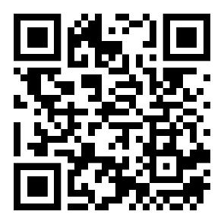

<https://forms.gle/VEXu3TZy1DhiQos36>

**Examples of Possible Misuse:**

1. Use of materials not specified in the operating instructions.
2. Non-compliance with the permissible parameters for processing the respective material.
3. Maintenance work on an unsecured machine.
4. Non-compliance with the operating instructions.
5. Placing an interfering object on the work surface.
6. Processing of materials that are too large or too heavy or insufficiently fixed or unsuitable for the machine.
7. Use of a tool system not intended for the material or machine.
8. Operating the machine without the safety devices provided or PPE.
9. Use of modified module and tool systems.
10. Installation of spare parts and use of accessories and equipment not approved by the manufacturer.
11. Non-compliance with maintenance instructions.
12. Non-observance of signs of wear and damage.
13. Service work by untrained or unauthorized personnel.
14. Operating the machine although the operating instructions are incomplete or not available.
15. Deliberate or careless handling of the machine during operation.
16. Bypassing or changing the safety devices (e.g. because the user is hindered in his work by the safety device)

**C. Receiving of Samples**

1. The samples will not be received except after completion of the application form, Terms of Service, Lab safety rules and regulation documents and clarifying all the data submitted to the ATDRL.

2. The ATDRL is not responsible for samples delivered to any unauthorized personnel and /or without the approval of the ATDRL management.

3. Any change in the contents/ data supplied by the user in the application form will immediately lead to cancelling of any ATDRL obligations of delivering the samples or the data in the already determined dates, cancelling of the original application and cessation of any sample or data processing.

4. Samples may be subjected to partial or total damage during processing and the researcher will be notified before submitting the samples to the ATDRL.

5. Discarded samples will be delivered to the researcher for replacement within 2 working days otherwise the roll of samples processing will be changed and predetermined appointments will be subjected to delays and rescheduling of final data delivery dates.

6. The ATDRL facilities and equipment might go under service maintenance and/ or replacement, which may result in delays of services.

7. Consumables are provided by the researcher and the amounts and types will be determined before accepting the application of services.

8. The researchers are not allowed to extract data personally from the devices available inside the premises of ATDRL and if loss or corruption of data occurred because of researcher interference, the ATDRL will not be responsible of submitting any data or results to the researcher.

9. The researcher is responsible of delivering the samples in its recommended condition/s, container/s and/or safe environment for processing and should mention all the necessary information for storage condition before, during and after sample testing.

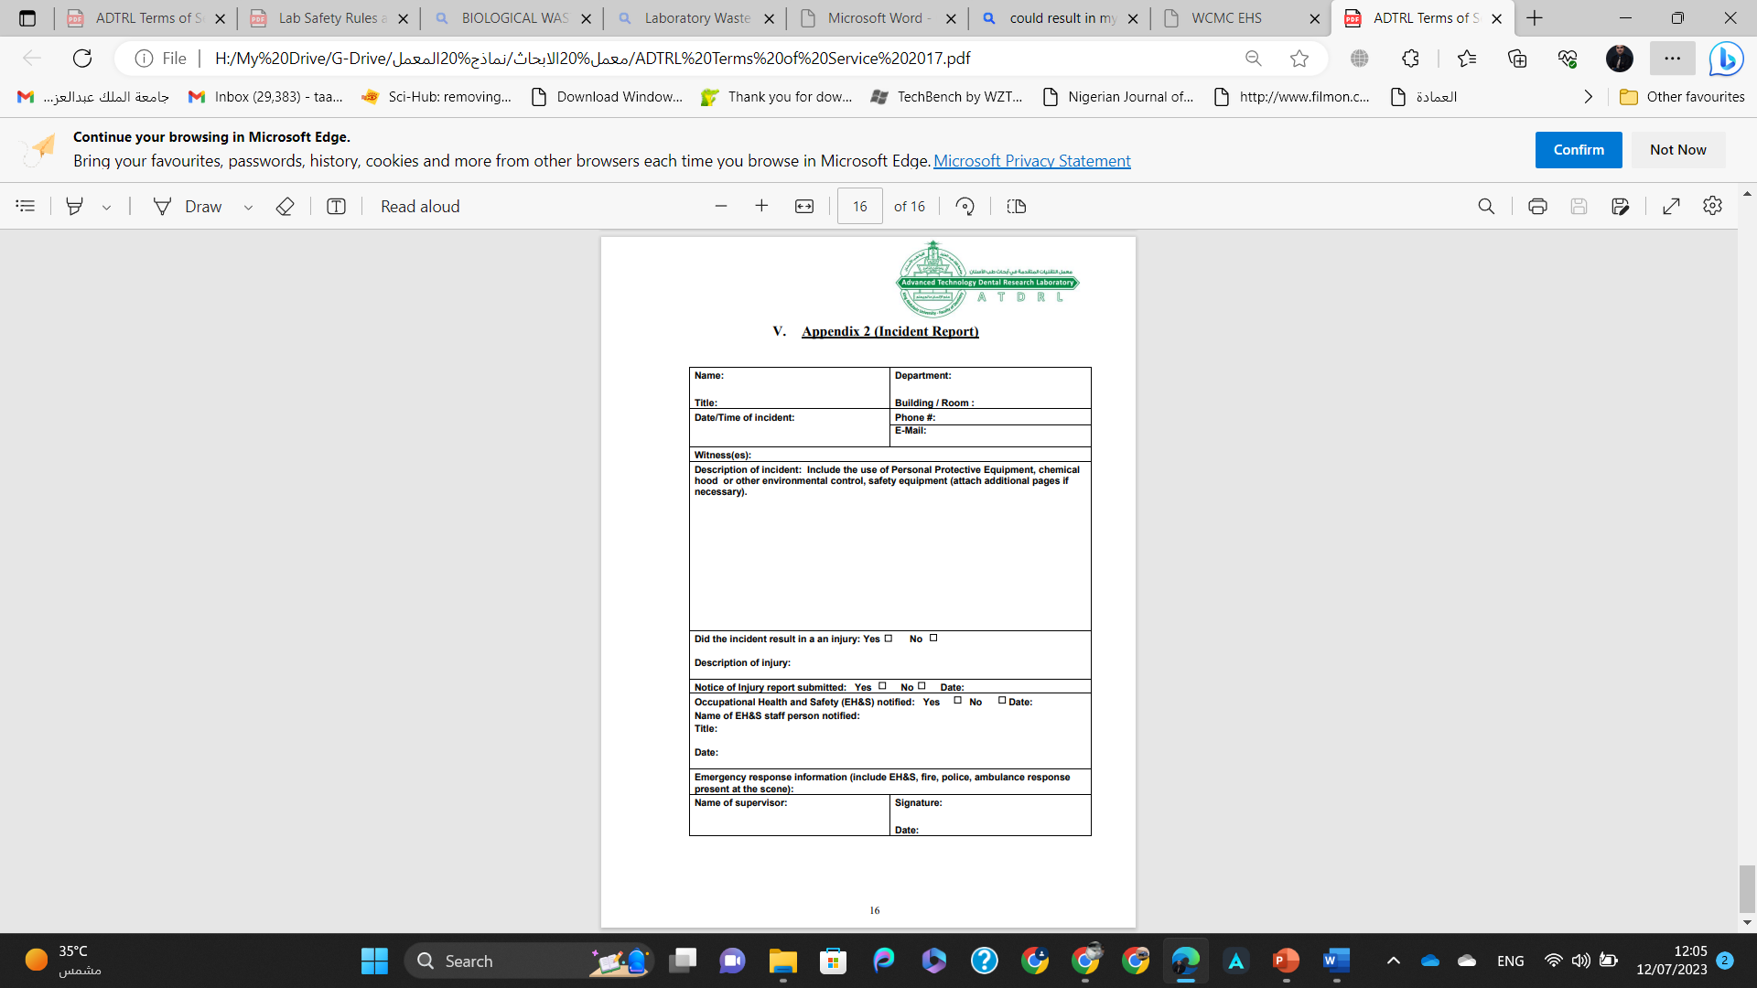**D. Appendix: (Incident Report)**

**ATDRL USER SAFETY CONTRACT**

I,............................................................................................................................................................................................................. (Name of the principle researcher/investigator in charge of the project) have thoroughly read the **LAB SAFETY & REGULATIONS** and do hereby agree to follow all safety rules and regulations given therein. I and my RESEARCH TEAM will conduct the research project in a safe and conscientious manner in the laboratory. I will not perform any unauthorized lab procedure. I understand that misuse, misbehaviour or misconduct in the lab or failure to follow safe lab procedures could cause a serious accident. I further understand that violation of these rules and regulations could result in disciplinary action, lawsuits, and prohibition from accessing ATDRL facility.

**I noticed the location of the following safety equipment at ATDRL facility, and I know how to use them in case of emergency:**

* Fire extinguishers.
* Eye washes.
* First aid kits.
* All emergency exits from room.
* Alarm & Assembly areas.

|  |  |
| --- | --- |
| **Date** |  |
| **Principal Investigator/Researcher ID Number**  *(KAU ID Number for KAU Users)*  *(National ID Number for Non-KAU Users)* |  |
| **Principal Investigator/Researcher signature** |  |
| **1st Co-Researcher Name and signature** |  |
| **2nd Co-Researcher Name and signature** |  |
| **3rd Co-Researcher Name and signature** |  |