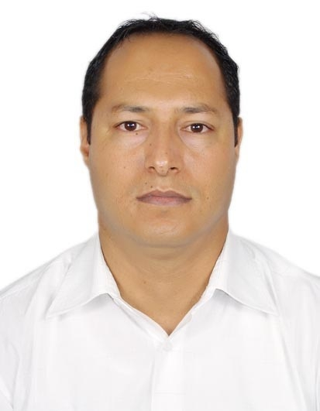
Curriculum Vitae

- Name : Mohamed Elkamel
- Surname : BAKARI
- Date of Birth : 10 – 06 – 1972
- Place of Birth : Sidi Bouzid, Tunisia
- Mail address: P.O. Box 80347 Jeddah 21589. Kingdom of Saudi Arabia.
- Permanent address: 24 rue de la Poste, Sidi Bouzid 9100. Tunisia.
- Phone Numbers: (+966) 055 465 3009.
(+216) 97 098 074.
(+216) 76 622 123.
- E-mail : kamel3_2000@yahoo.com

- Qualifications:

- September 2007: Enrolment in Ph.D. Research Programme in The Faculty of Arts and Human Sciences - Tunis I, Mannouba University, Tunis, Tunisia.

- 2002: A certificate of comparability from UK NARIC - The National Recognition Information Centre for the United Kingdom - certifying that my BA and MA are equivalent to BA and MA in British qualification.

- 1998 to 2002: Master’s Degree (DEA) in English – speciality: Civilisation and Cultural Studies. Distinction: with Honours. (Mark: 16/20) from The Faculty of Arts and Human Sciences, Tunis I, Mannouba University, Tunis, Tunisia.
- June 1997: Advanced Studies Diploma in Education Sciences from the Faculty of Arts and Human Sciences- Tunis I, Mannouba University, Tunis, Tunisia.

- 1993 to 1997: Bachelor of Arts (Maitrise) in English. Distinction: with Honours, from the Faculty of Arts and Human Sciences - Tunis I, Mannouba University, Tunis, Tunisia.
- 1993: Baccalaureate in Arts from the Secondary Mixed School, Sidi Bouzid, Tunisia.

- Academic and Pedagogical Training :

- September 2006 to January 2007: Computer Training on the use of
“Class-Server” computerized programme of e-learning.
Dar Al-F ikr School, Jeddah, Saudi Arabia.

- 2001 to 2002: An academic research period to prepare for a Ph.D. thesis in Derby University and Nottingham University, Derbyshire, England, the UK.
- February 2002: Attending the Mentoring.net Course for Overseas Trained Teachers organised by Teaching Personnel, London, England, the UK.
- 1998 to 1999: A pedagogical training period in the Teachers' Pedagogical Training Centre in Lessouda (CREFOC), Sidi Bouzid, Tunisia.
- July- August 1996: A cultural and language training in Castle Hill International Language Centre (CHILC), Lincolnshire, England, the UK.

- Professional Experience:

- 2007 - up to now: teaching English (TEFL/ EAP) at The English Language Center (ELC) in King Abdul-Aziz University, Jeddah, Kingdom of Saudi Arabia.

- 2004 to 2006: - teaching American History /Civilisation and cultural studies at the English Department, the Institute of Languages and Applied Human Sciences, Gafsa University, Gafsa, Tunisia.
- teaching TEFL/TESL, Composition/ Writing Skills/ Grammar/ Translation
- 2002 to 2005: teaching English (TEFL/ TESL) at the Higher Institute of Schoolmasters’ Training in Sbeitla, Kasserine, Tunisia.
- 2001 to 2002: A supply secondary school teacher (TEFL/TESL) in secondary schools in London, Nottingham, and Derbyshire, England, the UK.
- 2000 to 2001: A secondary school teacher of English (TEFL/TESL) in Preparatory School, Souk Jdid, Sidi Bouzid, Tunisia.
- 1998 to 2000 : A secondary school teacher of English (TEFL/TESL) in Mixed Secondary School, Sidi Bouzid, Tunisia.

- Research area and Publications:

- 2005/2006 : " Sustainable Human Devolopment as a new Paradigm in the North-South Debate", a tentative topic layout and bibliography for a Ph.D. in The Faculty of Arts and Human Sciences, Mannouba University, Tunis, Tunisia.

- 2002: "The Environmental Issue in the American Foreign Policy in the 1980s and 1990s: from Periphery to Centre Stage", a dissertation for MA in Cultural Studies from The Faculty of Arts and Human Sciences, Mannouba University, Tunis, Tunisia.
- 2000: “Teaching Vocabulary of English", written as an evaluation project in the pedagogical tarining in The Teachers' Pedagogical Training Centre in Lessouda (CREFOC), Sidi Bouzid, Tunisia.

- 1996: "Vegetariansim in the UK: Ethics and Practice", written as a writing project during the language training periond in Castle Hill International Language Centre (CHILC), Lincolnshire, England, the UK.

- Research Interests: Sustainable Development, Globalisation, North-South Debate, Environmentalism, International Relations.

- Other Skills and Fields of Experience :

- A good knowledge of using the educational and E-learning programmes: class-server programme, Word, PowerPoint.
- A wide experience in Computer Skills and the internet.
- A wide experience in using American curricula textbooks: Prentice Hall, Holt Rinehart and Winston, McGraw-Hill Interactions Access textbooks, and EAP textbook.
- A wide experience in translation and interpreting from Arabic into English and from English into Arabic.

- Languages :

* Arabic: excellent competence both spoken and written.
* English: excellent competence both spoken and written.
* French: fair competence both spoken and written.

- A wide experience in directing and organising English Clubs at educational institutions.

Referees:
Name: | Mr. Michael Callaghan
Address | P.O. BOX 122836. Jeddah 21332. Saudi Arabia
Telephone | (+966) 0504306920
E-mail: | -- mjc@teacher.com
Name: | DR. MONCEF DHAMBRI
Address | Department of English,The Faculty of Arts and Human Sciences, Mannouba University, Tunis, Tunisia.
Telephone | 0021698427687
Name: | DR. MOHAMED ALMANSOURI
Address | Department of English,The Faculty of Arts and Human Sciences, Mannouba University, Tunis, Tunisia.
Telephone | 0021698586511

